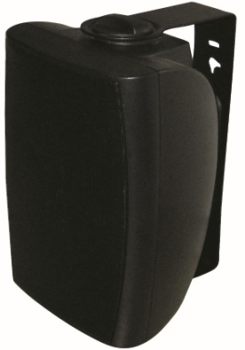
5" Two Way Wall Mount Speaker (30W)
FWS-530
Feature:
- Commercial PA system wall mount speaker with transformer
- Ideal for school, office, hotel and airport background music system
- Economy rang fashion wall mount cabinet loudspeaker
- Rated power output 30W at 100V
- 5" woofer and 1.5” tweeter two way speaker units
- Line input 100V or 70V
- ABS enclosure, metal grille in black
- Quick installation by supplied stainless mounting bracket
Specification:
Model | FWS-530
Description | 5” Two Way Wall Mount Speaker
Rated Power Output | 30W
Line Input | 100V or 70V
Frequency Response | 100-20KHz
SPL(@1W/m) | 89dB
Speaker Unit | 5” woofer and 1.5” tweeter two way speaker units
Dimension | 275 (W)×185(D)×170(H)mm
Material | ABS enclosure and metal grille in black
Mounting Way | Quick installation by supplied stainless mounting bracket
Weight | 3.1kg

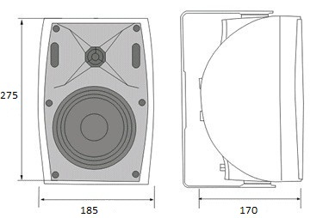
Side View & Dimensions:

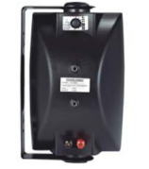

Frequency Response VS SPL Diagram:
